|  |
| --- |
| E-Gram Seva |
| Software Design Specification v1.0 |
| Team 22 February 25, 2013 |

|  |
| --- |
|  |

**REVISION HISTORY**

|  |  |  |
| --- | --- | --- |
| **Version** | **Author** | **Date** |
| Version 1 | Abhishek Shukla, Krish Mahajan | February 25, 2013 |
| Review Version 1 | Sahil Sikka | February 26, 2013 |

**CONTENTS**

1. **Introduction………………………………………………………………………………..…..4**
   1. Purpose……………………………………………………………………………………...4
   2. Scope…………………………………………………………………………….………..…4

1.2.1 Present……………………………………………………………………………4

1.2.2 Future…………………………………………………………………….….……4

* 1. Reference Material………………………………………………………………………….4

1.4 Definitions, acronyms and abbreviations………………………………………………...4

1. **System Overview ……………………………………………………………………...……...5**

2.1 Interfaces …………………………………………………………………………………...5

2.1.1 Software Interface……………………………………………………………….5

2.1.2 Hardware Interface………………………………………………………………5

2.1.3 Communication Interface……………………………………………………….5

1. **System Architecture…………………………………………………………………………..6**

3.1 Architectural Design……………………………………………………………………..….6

3.2 Data Decomposition…………………………………………………….……………..…...9

3.3 Use Cases……………………………………………………………………………….....13

1. **Data Design…………………………………………………………………………………….14**

**5. Detailed Design………………………………………………………………………….....….16**

**6. User Interface…………………………………………………………………………………..18**

**1. Introduction**

**1.1. Purpose**

This software design document describes the architecture and system design of our software, E-Gram Seva. It will act as a reference for each member of the group covering the design and details for all the functionalities of the software.   
This document helps us obtain:

* Low-Level Design of our Software.
* Different modules and components to be implemented.
* Entry document for Coding Phase.

**1.2. Project Scope**

**1.2.1. Present Scope**

Our web based application aims to provide agriculture related news like prices of grains, weather forecast and, in addition, health-care updates easily available to the villagers (end users) specifically. This will facilitate governmental and non-governmental organizations to provide information to the villagers and spread awareness among them.

**1.2.2. Future Scope**

This software usability can be extended by adding more features such as more updates as per the requirements of the end users. This includes job facilities, general bulletin etc.

**1.3. Reference Material**

* SRS
* Pressman, Roger S., and Darrel Ince. Software engineering: a practitioner's approach. Vol. 5. New York: McGraw-hill, 1992.

**1.4. Definition and Acronyms**

**SRS** System Requirement Specification

**SDD** Software Design Document

**DFD** Data Flow Diagram

**GUI** Graphical User Interface

**SMS** Short Message Service

**KDLOC** Kilo Delivered Lines of Code

**PHP** Personalized Home Page

**DA-IICT** Dhirubhai Ambani Institute of Information and Communication Technology

**2. System Overview**

This document is created after the requirements are clearly understood in Requirements phase. It describes in detail how various modules are implemented.

The system will follow the three-tier architectural style and be organized into three layers:

* Interface layer
* Application layer
* Storage layer

The Interface layer will be the graphical user interface that allows the users to interact with the system (Website). It will be implemented using Dreamweaver.

The Application layer will contain the logic and algorithm depending on which SMS’s will be delivered to end user. The users can query the health-related information and its implementation is different.

Finally, the Storage layer will form a database to store the metadata required for the system. For our software, we require the information about the end users (mobile number, subscription details) to be stored in the database. Also, the updates to be sent through message are stored in the database.

**2.1 Interfaces**

**2.1.1 Software Interface**

We will use WAMP server. MySql is used as the database server. Ozeki, an SMS server is used for integration between the computer and the phone. Dreamweaver will be used for website development.

**2.1.2Hardware Interface**

Our computer system will require the following minimum. The computer system is to be equipped with Intel Pentium 4 or above, 256 MB RAM or above, disk Space enough for database storage.

A registered sim card is required whose validity expiration is taken care of.

**2.1.3 Communication Interface**

The messages are transferred using the telecom service of SMS.

HTTP is the underlying protocol used for the operation of the website.

**3. System Architecture**

**3.1 Architectural Design**

The whole system has been divided into the following modules:

* Login Module
* Admin Module
* User Module
* Client SMS Module
* User SMS Module.
* **Login Module**

This module enables the users to login with username and password provided by the administrator. It also enables administrator to login and scrutinize user statistics.

LOGIN

USER

ADMIN

SERVER

* **User Module**

This Module enables users to:

* Register for the SMS updates
* To change their subscription preferences,
* To change their password
* To retrieve forgot password

USER LOGIN

USER_REG

FORGOT_PASSW

SERVER

CHANGE_PASS

* **Admin Module**

This module enables admin to login to his account where he can analyze user statistics.

ADMIN

USER_STATS

ADMIN_DETAILS

SERVER

* **User Send SMS**

This module enables user

* To send queries regarding health-care.
* To register for eGram-Seva through SMSs.
* To change subscription through SMSs.

USER

HEALTH_QUERY

SMS_REGISTRATIONN

SERVER

* **Admin Send SMS**

This module enables admin to

* Send password to users who register
* Send updates of prices and weather as per the subscription of the respective users.
* Send response to users healthcare-related queries.

ADMIN_SMS

SEND_PASSWORD

SEND_UPDATES

HEALTH_QUERY_REPLY

SERVER

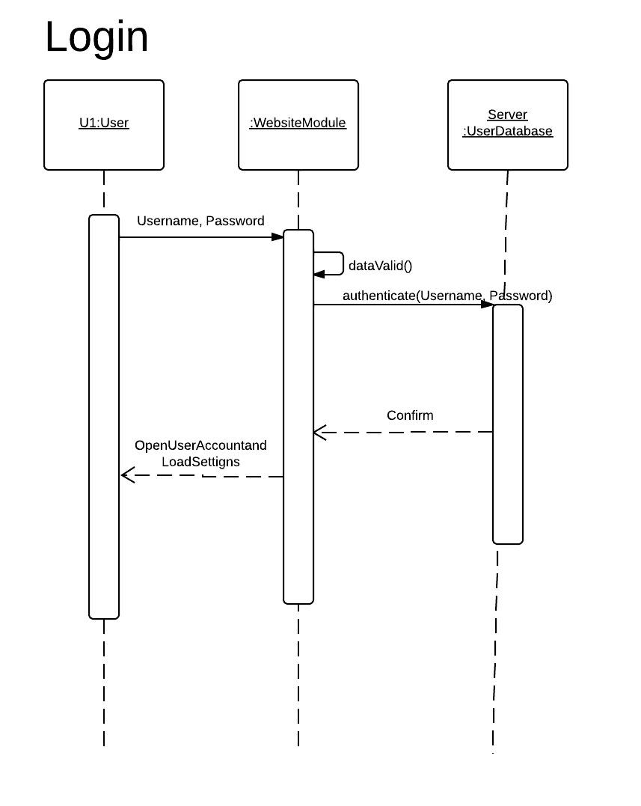

The user enters his username and password to login at the website. It is authenticated and if correct, the user’s personal account is opened. dataValid() checks if the entered information is correct. (Only numbers and special characters allowed)

**3.2 Data Decomposition**

Sequence Diagrams are used in this section to depict the interaction and flow among the various different objects of our software in a sequential manner.

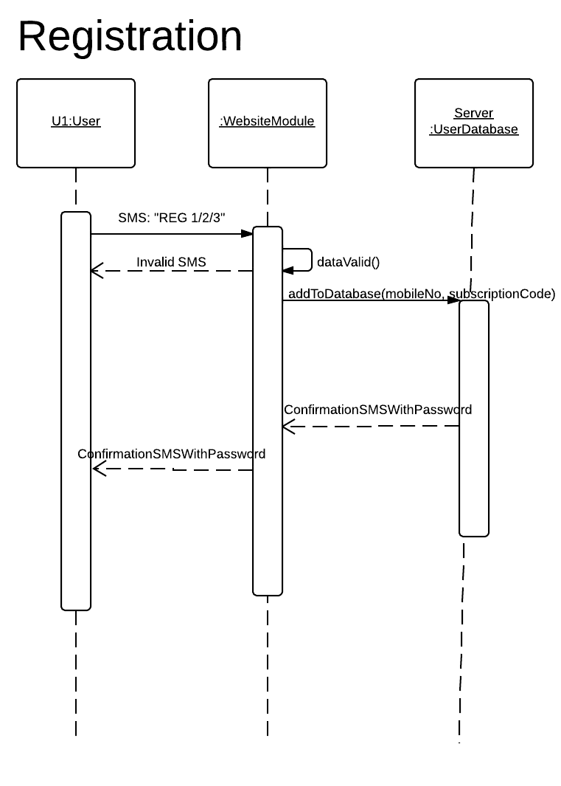

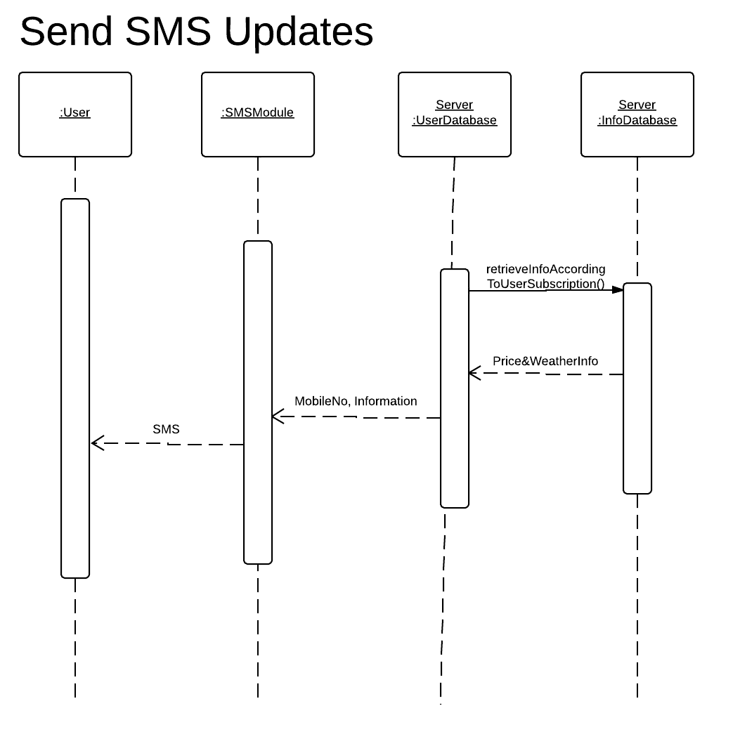

The user sends SMS in the standard format: “REG 1/2/3”. If the format is followed, the details of the user’s number and subscription are sent to the database for storage and a confirmation message is sent to the user with a randomly generated password for his user account.

According to the individual subscription, each registered user is sent daily updates. retrieveInfo() gets this information to be messaged from the InfoDatabase and uses the UserDatabase to get the mobile numbers to which to message. The SMS is then sent.

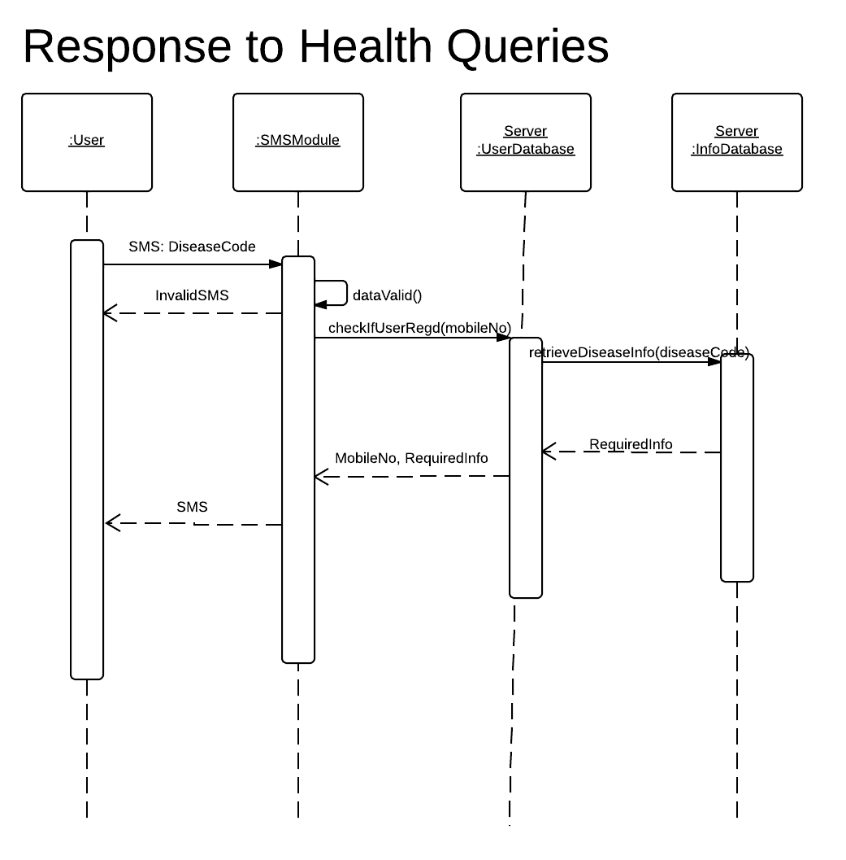

When a user sends a query message for a particular disease, it’s response is obtained from InfoDatabse after checking the format of the message as well as if the user is registered for service. The SMS is then sent.

**3.3 Use Cases**

Use cases are diagrams that represent the relationship between a use case (a requirement) and the actor. Actors are human beings, systems or devices which will use the system and/or maintain it.

|  |  |  |
| --- | --- | --- |
| S.No | Symbol | Meaning |
| 1 |  | Association |
| 2 |  | Use-case |
| 3 | hero.PNG | Actor |

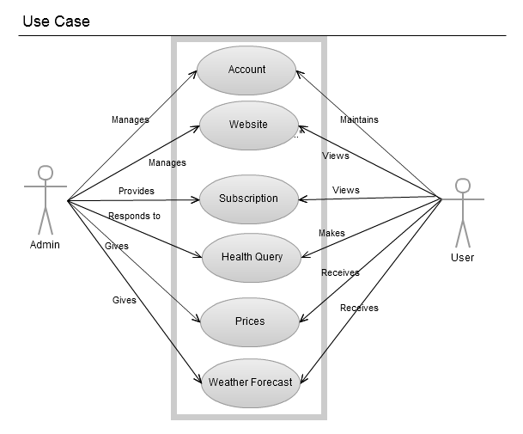

The website has separate user and admin accounts. The interaction of both the profiles in relation to the various features has been depicted in the use case diagram above.

**4. Data Design**

This section describes the design of the SQL database that will be used to store information regarding the service, namely, the users registered (along with their passwords and subscriptions) and the information to be sent through SMS.

Following is the ER Diagram of the database which depicts the relationship of the tables:

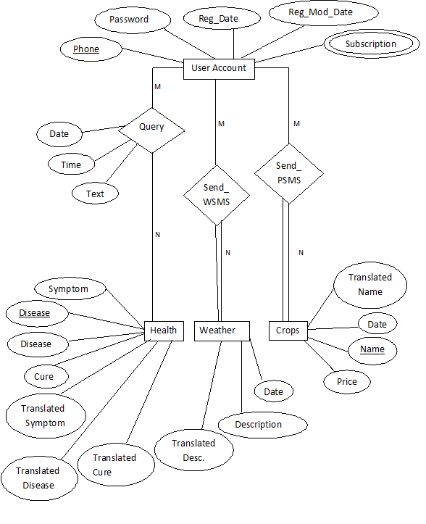

The following relational schema depicts the tables and the attributes each one has.

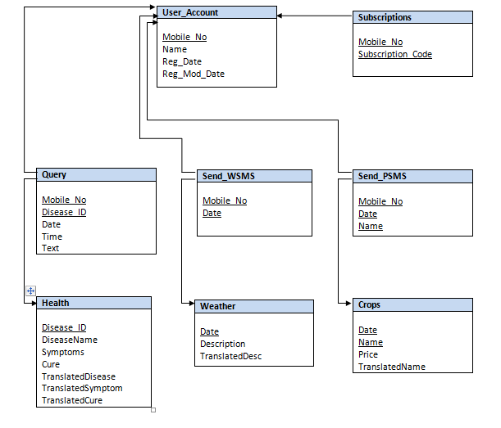

**5. Detailed Design**

Activity Diagrams are used to graphically represent the workflow in detail depicting the activities in a stepwise and sequential manner.

* **Login  
    
  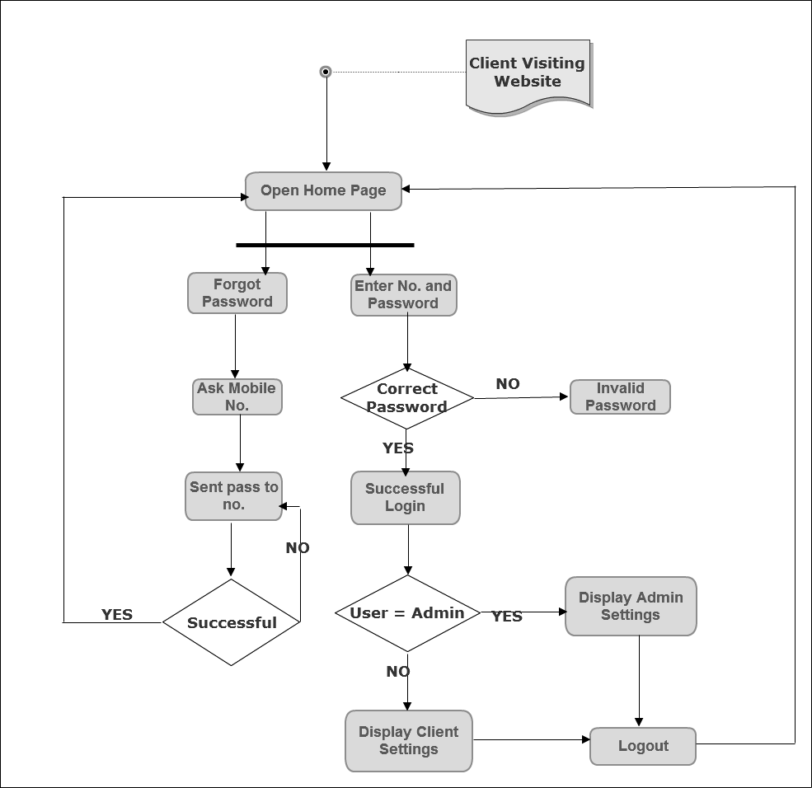**

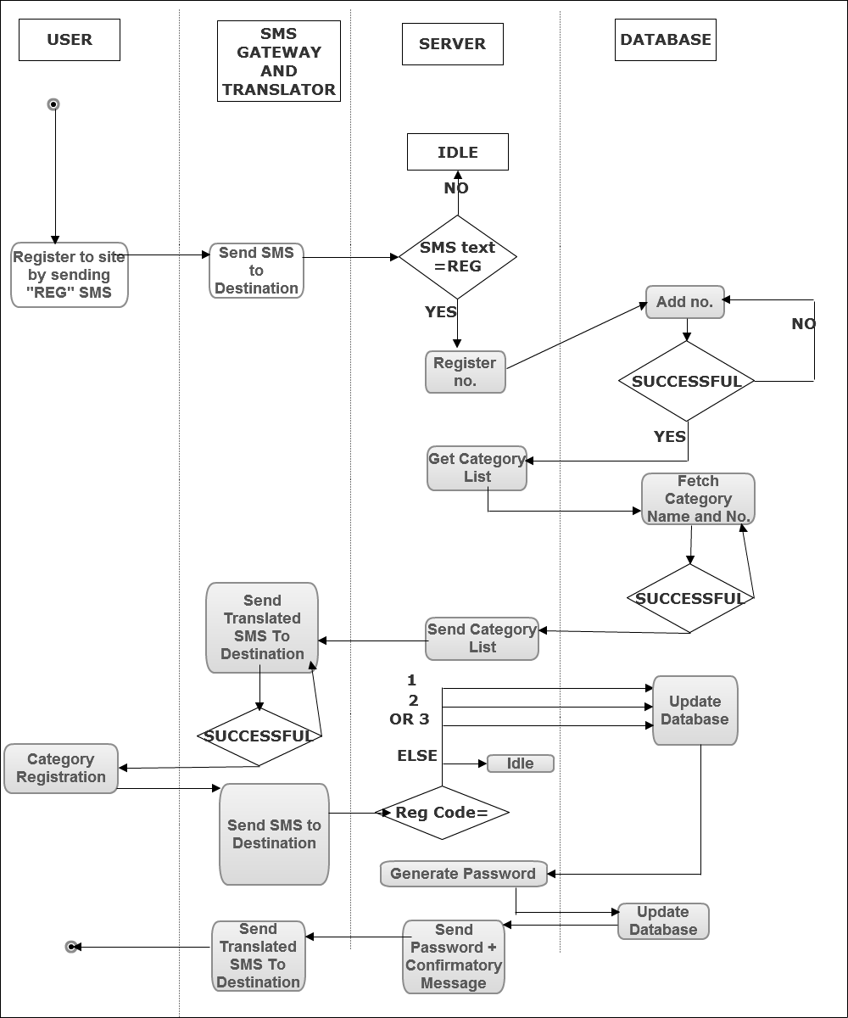

* **Registration**

**6. User Interface**

This section shows the website interface and the web pages provided for facilitating the users. The SMS service does not have a distinct interface and is in accordance with the respective handsets of the users.

* Homepage

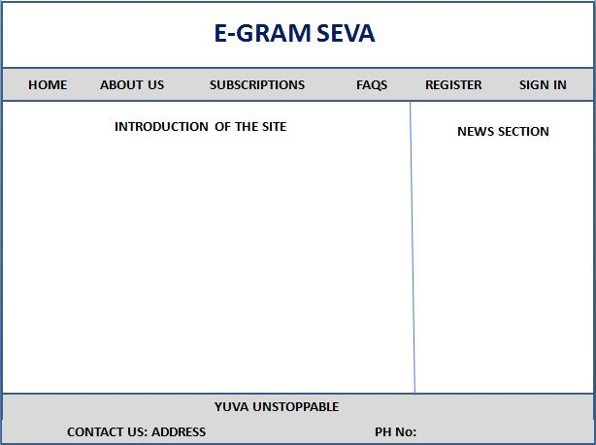

* About Us Page

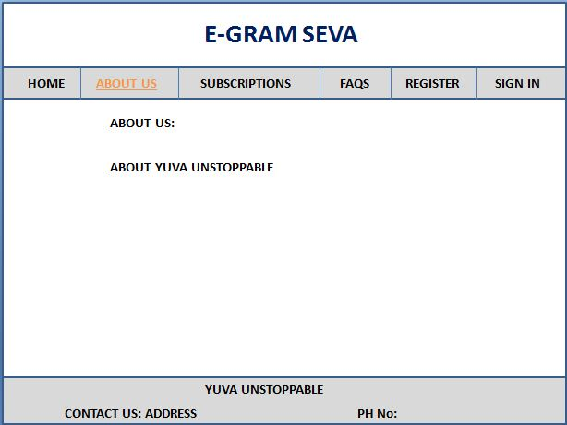

* FAQs Page

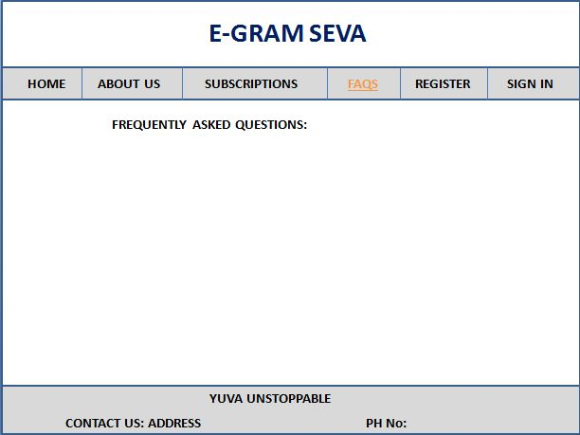

* Registration Page (Sign Up)

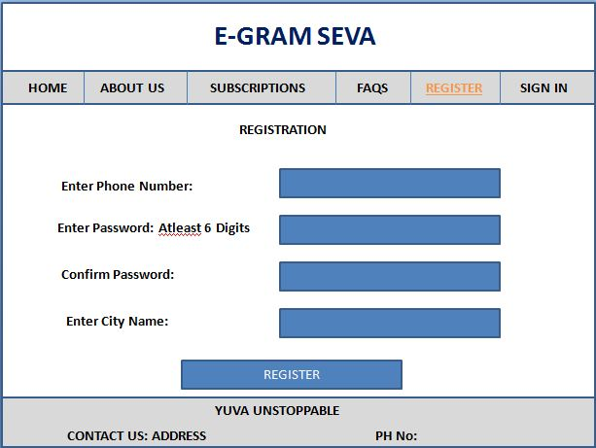

* Login Page

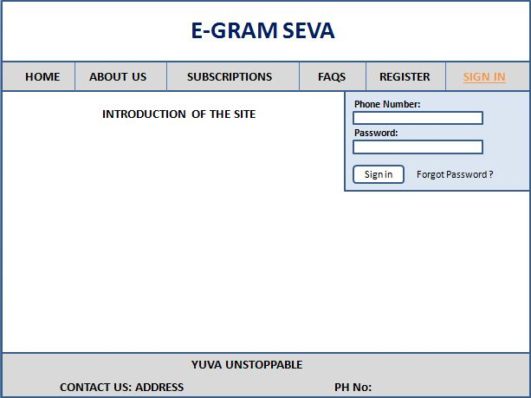

* Open Information Page According to Subscription Caetgory

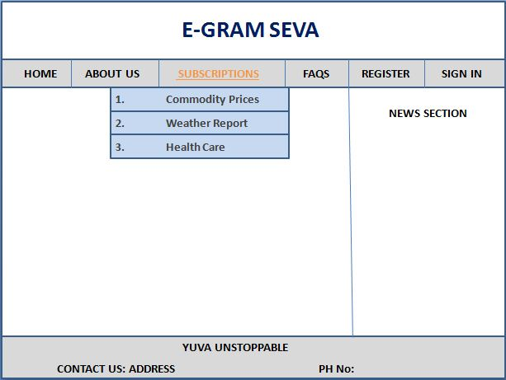

* Prices of Crops Page

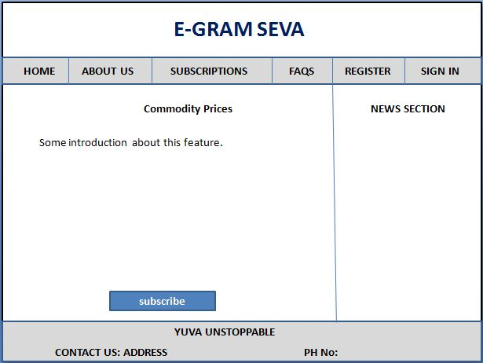

* Weather Information Page

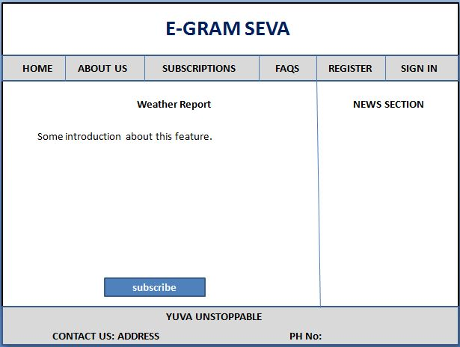

* Health Care Page

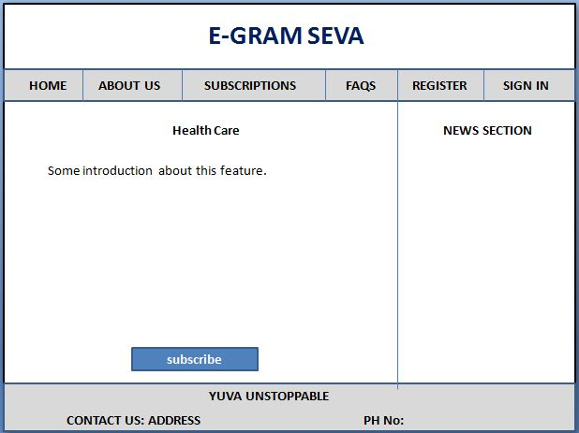

* User Account (after login)

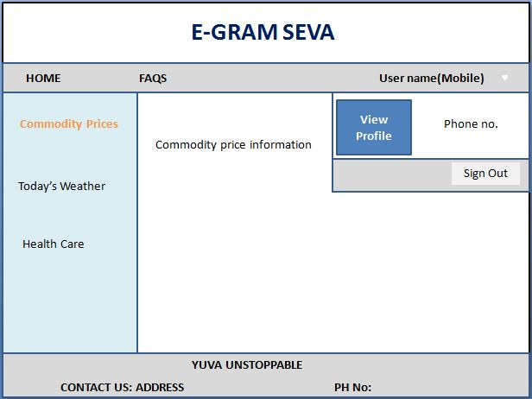

* User Account (Choose different categories)

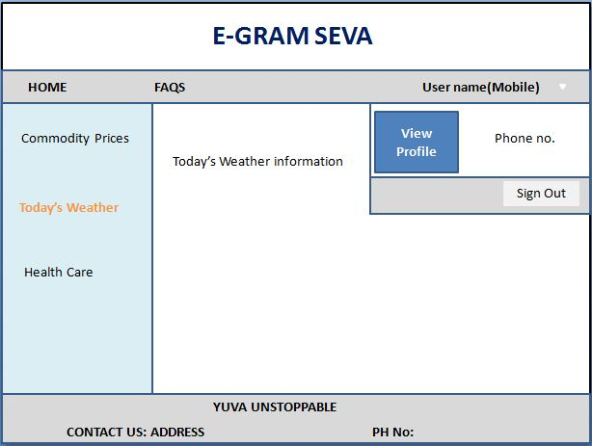

* User Account (Health Care Information)

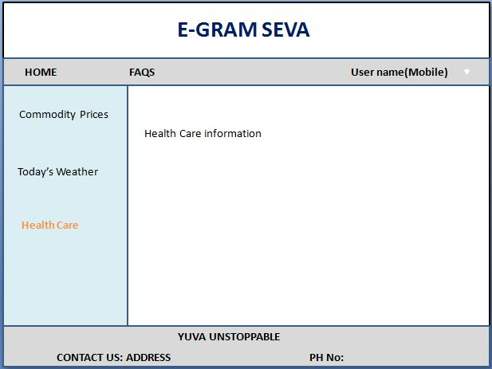

* Admin Account (View Users Registered)

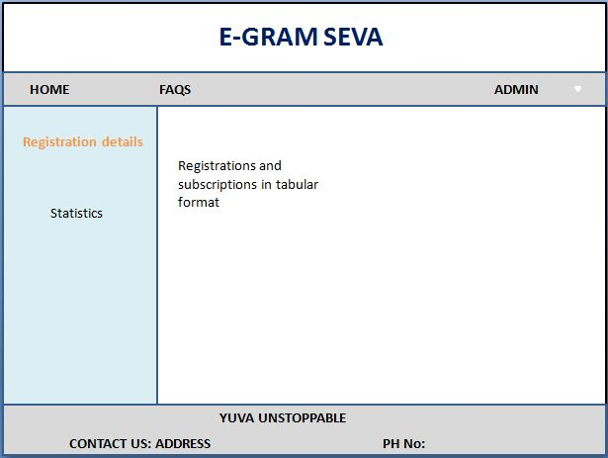

* Admin Account (Service Statistics)

